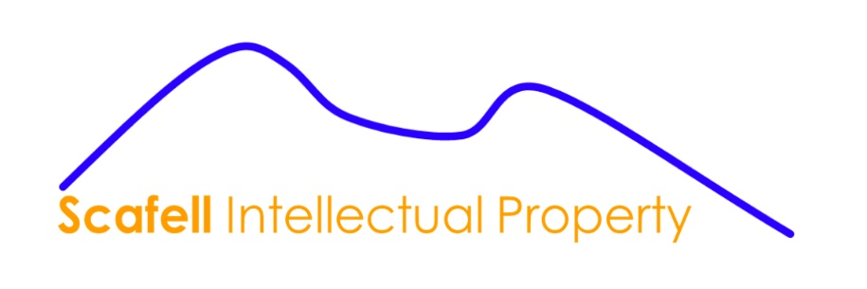 **GENERAL TERMS AND CONCITIONS SCAFELL INTELLECTUAL PROPERTY**

1.

Scafell Intellectual Property is a company which provides services in the field of Intellectual Property and is registered with the Chamber of Commerce of the Netherlands under number 91347688.

2.

These general terms and conditions apply exclusively to all assignments, quotations, offers and work that are accepted, executed or issued by or on behalf of Scafell Intellectual Property. Scafell Intellectual Property is the sole contractor of all activities. If these general terms and conditions become applicable to an agreement with the client, they also apply to other assignments that have been or will be concluded with the same client. If general terms and conditions already exist with the client, the applicability of the new general terms and conditions replaces the applicability of the previous general terms and conditions. No agreement is ever concluded between the client and the person who actually carries out the assignment or is involved in it, even if the assignment is provided by that person as referred to in Article 7:404 of the Dutch Civil Code with a view to the execution. The applicability of Articles 7:404 of the Dutch Civil Code and 7:407 paragraph 2 of the Dutch Civil Code is excluded, so that not the professional but only Scafell Intellectual Property is obliged to carry out the assignment and therefore only Scafell Intellectual Property can be liable for a shortcoming in this regard.

3.

Scafell Intellectual Property will take the care of a good contractor into account when carrying out the assignments. Scafell Intellectual Property is not responsible for achieving the intended result.

4.

Assignments are carried out exclusively for the benefit of the client. Third parties cannot derive any rights from this.

5.

If third parties are engaged in connection with the execution of the assignment given to Scafell Intellectual Property, Scafell Intellectual Property will consult with the client about the third parties to be engaged. Any liability for Scafell Intellectual Property as a result of shortcomings of the third party engaged is excluded. The client authorises Scafell Intellectual Property to accept the general terms and conditions, including any limitations of liability, stipulated by this third party on behalf of the client.

6.

The client agrees that Scafell Intellectual Property uses digital means of communication, data storage services, equipment, software, data and files, registers and/or other matters in the execution of the assignment. Scafell Intellectual Property is not liable for damage resulting from its use. Scafell Intellectual Property is not liable for damage resulting from unauthorised access to, inaccessibility of, accidental distribution of, loss of and/or damage of (part of) the data, (computer) files and/or the (digital) networks, servers, workplaces, (peripheral) equipment, software, digital means of communication and/or services for storage of data and files.

7.

Except in the event of intent or gross negligence on the part of Scafell Intellectual Property, a client indemnifies Scafell Intellectual Property against all claims that a third party believes it has against Scafell Intellectual Property in connection with an assignment given to Scafell Intellectual Property, including damage, costs and expenses that Scafell Intellectual Property suffers or incurs in relation to such a claim.

8.

Scafell Intellectual Property excludes any liability for damage, including but not limited to, damage caused by one or more of individual professionals, trademark attorneys, patent attorneys, lawyers and/or all persons who carry out or have carried out the work on behalf of the client and damage that can otherwise be attributed to Scafell Intellectual Property, unless the client demonstrates that the damage suffered by him/her was caused by intent or gross negligence on the part of Scafell Intellectual Property. Should the execution of an assignment lead to liability, the liability of Scafell Intellectual Property, the individual professionals, the agents and all persons who carry out or have carried out the work on behalf of the client, are or have been involved in this, is always limited in total to the amount that is paid out under the professional liability insurance of Scafell Intellectual Property in the relevant case, plus the amount of the deductible that is borne by Scafell Intellectual Property under the policy of that insurance in the relevant situation. The contractor is only liable for direct damage and never for indirect damage, including consequential damage, loss of profit, missed savings and damage due to business interruption. The limitation of liability also applies if Scafell Intellectual Property wrongly refuses an assignment and damage results from this. Scafell Intellectual Property, the individual professionals, the authorised representatives and all persons who carry out or have carried out the work on behalf of the client, are or have been involved in this, may invoke these general terms and conditions and the limitation of liability provisions contained therein vis-à-vis the client, even if they are held liable on a non-contractual basis, such as tort. The client waives all rights of action against individual professionals, the authorised representatives and all persons who carry out or have carried out the work on behalf of the client, are or have been involved in this, and waives his or her right to hold the aforementioned individual professionals, the authorised representatives and persons themselves liable. To the extent necessary/possible, the provisions of these general terms and conditions (also) apply as third-party clauses for the benefit of the persons mentioned in this article. The client indemnifies Scafell Intellectual Property and the persons mentioned in this article against liability by third parties in connection with the assignment given, except insofar as insurance would make a payment in connection with such liability in the absence of this clause.

9.

Should the insurance, for whatever reason, not pay out, the total liability of Scafell Intellectual Property and of the persons mentioned in Article 5 for damage, on whatever legal basis, is limited to the amount charged for the assignment in question, up to a maximum of € 15,000.00 (in words: fifteen thousand euros) excluding VAT.

10.

If the client is of the opinion that Scafell Intellectual Property has failed in the execution of the assignment, the client must inform Scafell Intellectual Property in writing within 30 days after the client has discovered or reasonably should have discovered the shortcoming, failing which the claim for compensation and other rights in connection with the shortcoming lapses. Legal claims against Scafell Intellectual Property for the payment of compensation lapse by the expiry of one year after the day on which the client became aware of the damage, or could reasonably have been aware, and the possible liability of Scafell Intellectual Property for that damage.

11.

Scafell Intellectual Property is not liable for damage caused by inaccuracy and/or incompleteness of official registers, classifications, indices, computer databases consulted by Scafell Intellectual Property and not for damage caused by the client providing its incorrect or incomplete information.

12.

Scafell Intellectual Property declares the work it performs on a monthly basis, unless Scafell Intellectual Property agrees otherwise with a client. The claims must be paid no later than 14 days after the date of the invoice. If the payment is not made in time, Scafell Intellectual Property has the right to charge the statutory (commercial) interest on the unpaid amount. Scafell Intellectual Property is also entitled to suspend its services until a client has fully fulfilled its payment obligations. Scafell Intellectual Property is not liable for damage that arises as a result. Scafell Intellectual Property is entitled to change its rates periodically for both already accepted and new assignments.

13.

Scafell Intellectual Property is entitled to request an advance payment for the execution of the work and associated costs. These are settled at the end of the assignment or in the meantime.

14.

If a client has objections to a declaration, this objection must be made known to Scafell Intellectual Property within 14 days of the date of the declaration. If this is not done within this period, the client’s right to revise the relevant invoice lapses.

15.

If an assignment has been issued by more than one client, all clients are jointly and severally liable for the fulfilment of the obligations under these conditions, regardless of the name of a quotation, order confirmation or invoice.

16.

The legal relationship between the client and Scafell Intellectual Property is exclusively governed by Dutch law. Unless the applicable mandatory law prescribes otherwise, any dispute relating to the representation of Scafell Intellectual Property will be settled by the Court of Amsterdam, the Netherlands.

17.

By using the products and/or services of Scafell Intellectual Property, the client agrees that Scafell Intellectual Property processes (personal) data of the client in accordance with the General Data Protection Regulation. The Client agrees to the inclusion of the (personal or company) data of the Client in the digital and administrative systems of Scafell Intellectual Property.

18.

Both parties are entitled to terminate the contract by termination, if desired with immediate effect. However, in the event of a termination, a client must pay the declarations, which relate to work carried out by Scafell Intellectual Property up to the moment of termination.

19.

In the event of a conflict or a dispute of interpretation between the Dutch text of these general terms and conditions and the text thereof in another language, the Dutch text will be binding.

Scafell Intellectual Property has its registered office in Amstelveen and is registered in the trade register of the Chamber of Commerce of the Netherlands under number 91347688.